RED — Operations Practice Questions
Syllabus points: 1. Technology, task design and process layout · 2. New product or service design and development · 3. Supply chain management · 4. Inventory management · 5. Global factors · 6. Quality management. Questions are unchanged, exactly as they appear in the original papers.

1. Technology, task design and process layout
Barker Trial 2023 — Question 21 (c) (2 marks)
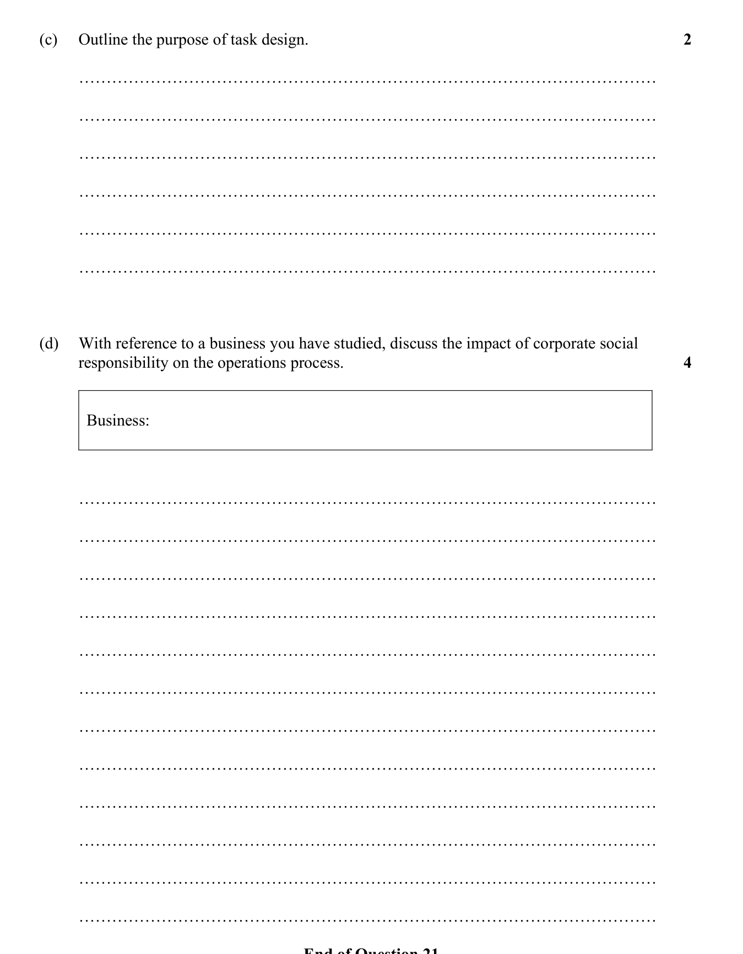
Barker Trial 2024 — Question 22 (b) (3 marks)
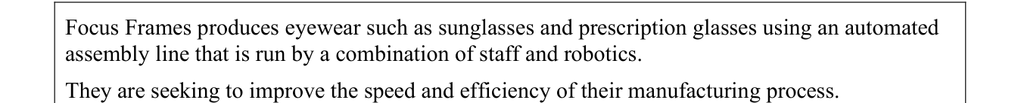
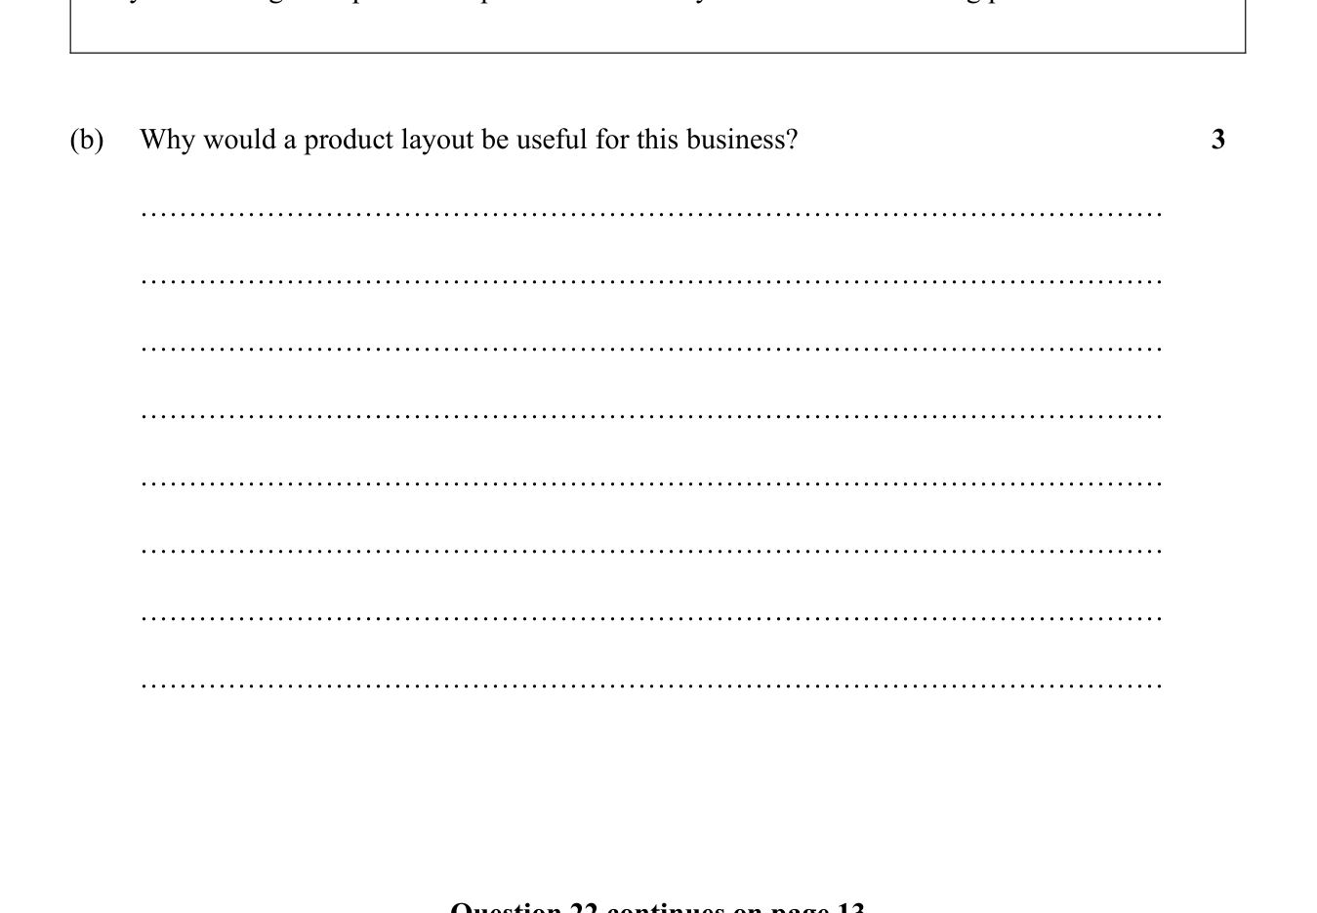

2. New product or service design and development
Newington Trial 2023 — Question 23 (b) (4 marks)
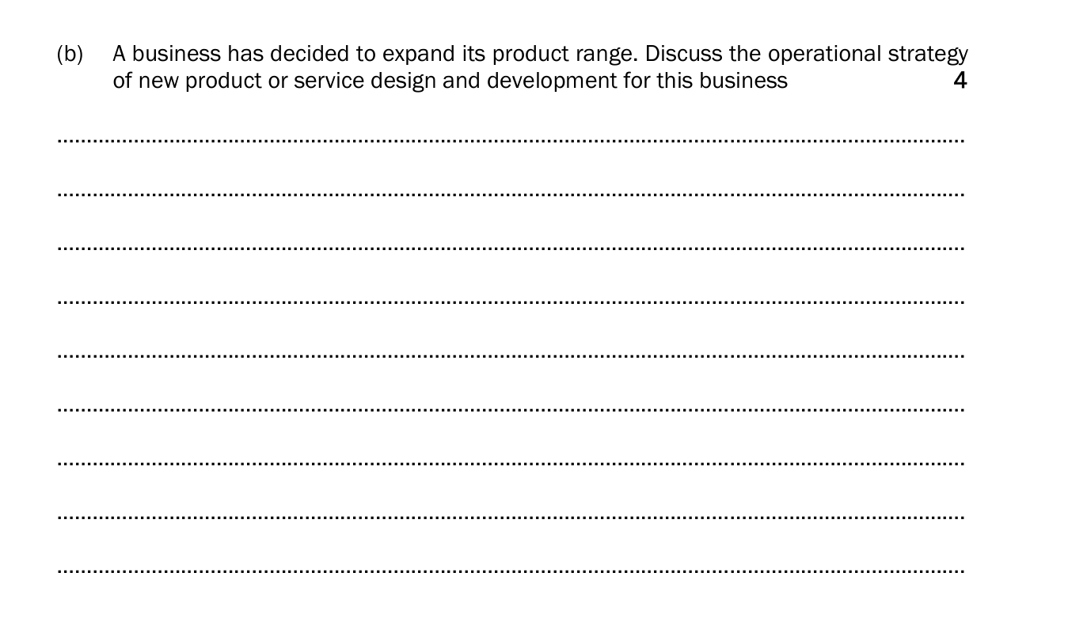

3. Supply chain management
2023 BoS Trials — Question 21 (4 marks)
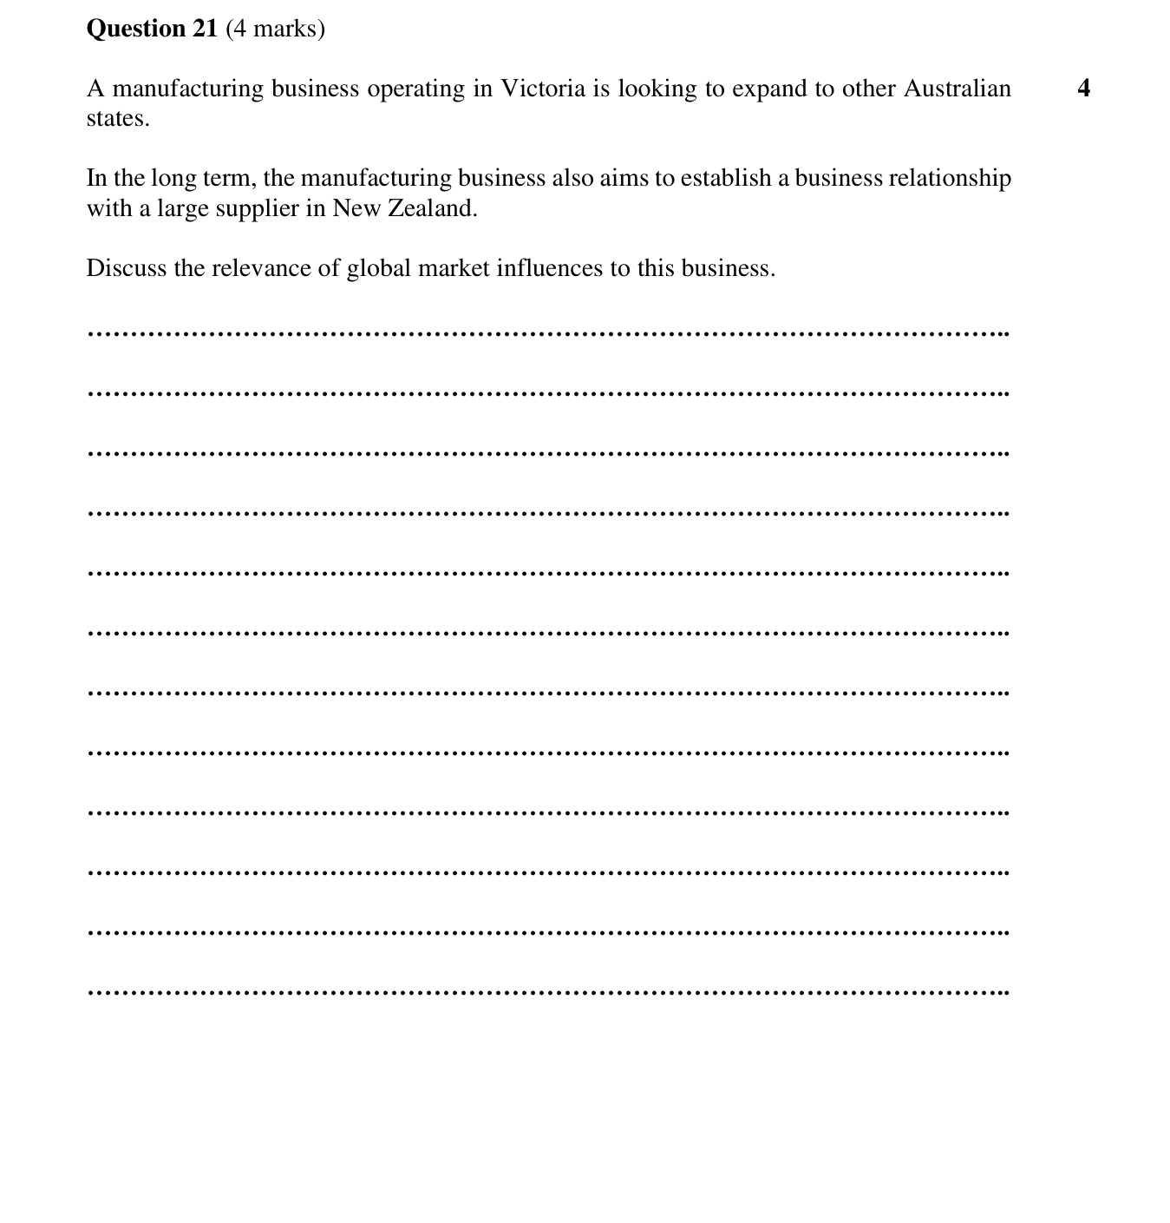

4. Inventory management
2023 BoS Trials — Question 26 (5 marks)
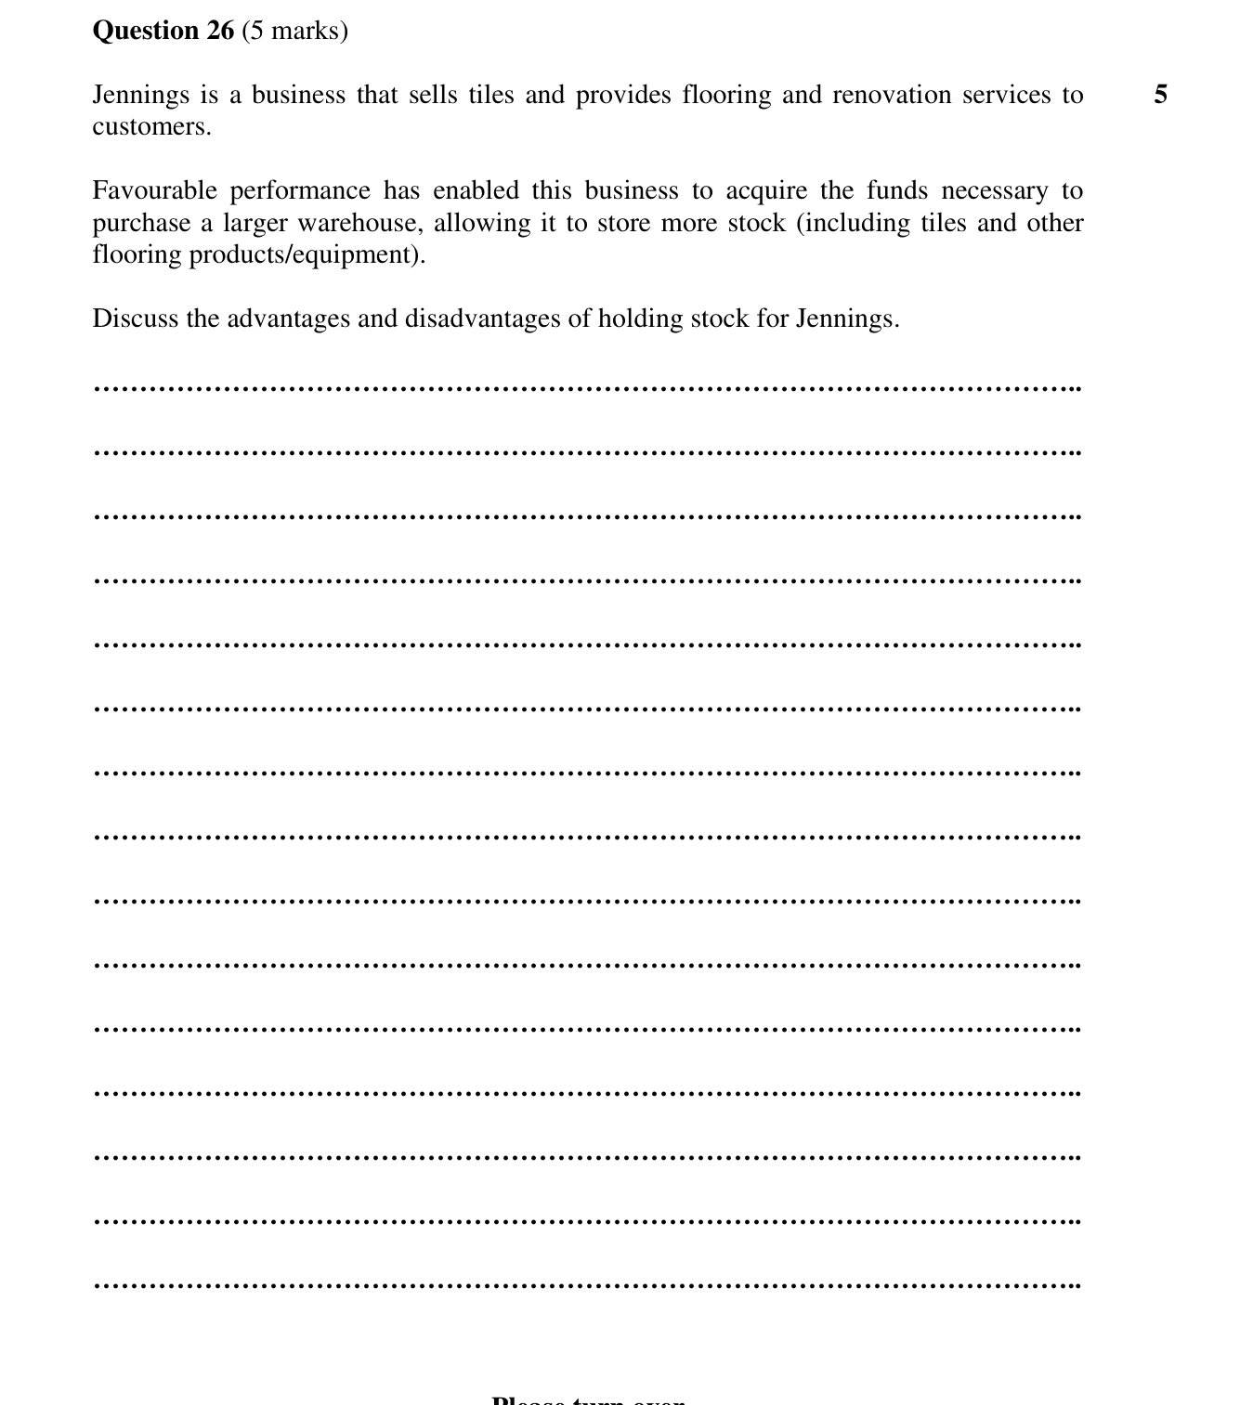
Reddam Trial 2023 — Question 21 (b) (2 marks)
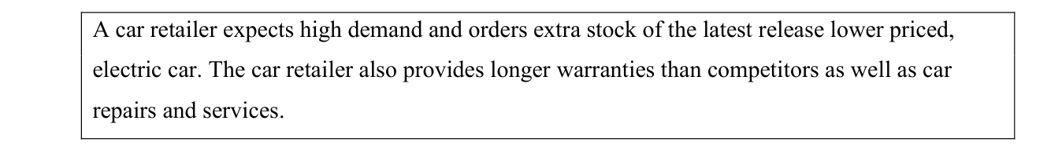
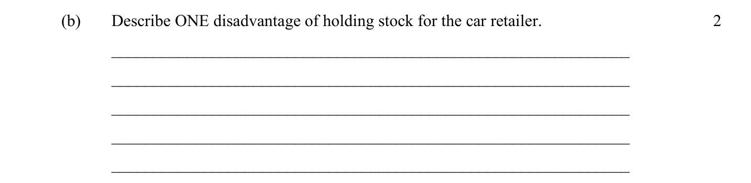

5. Global factors
Knox Trial 2023 — Question 22 (c) (5 marks)
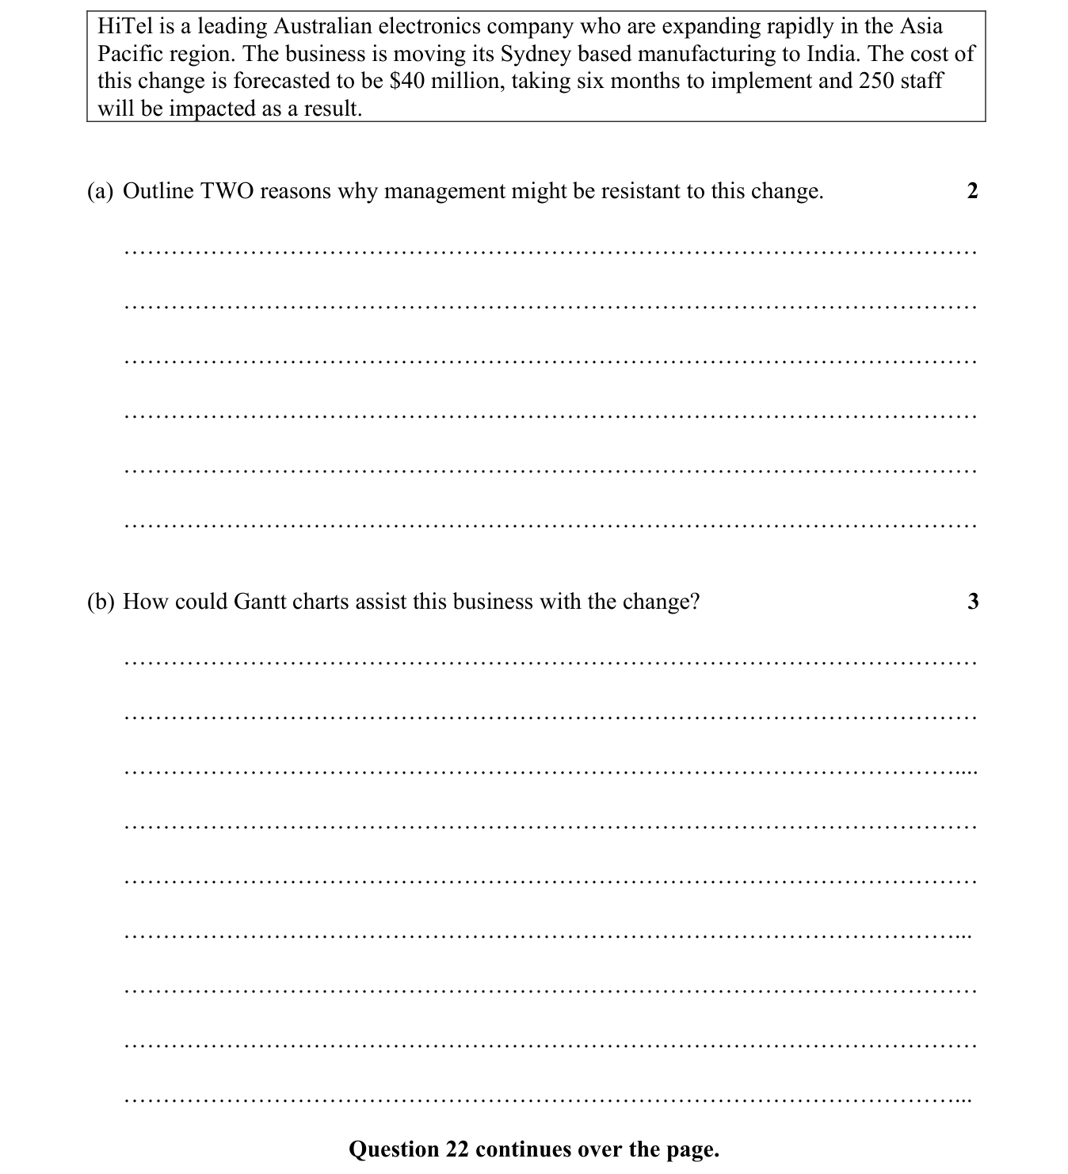
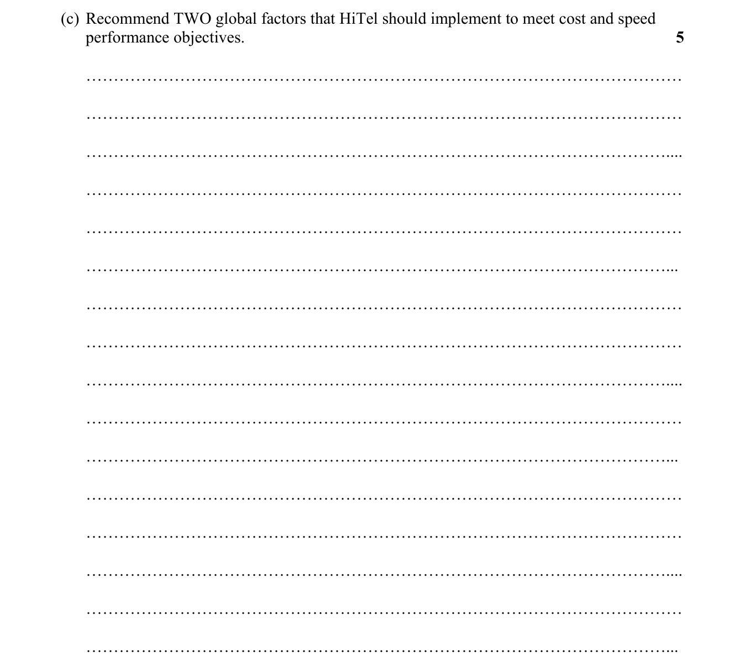
2023 HSC — Question 21 (b) (3 marks)
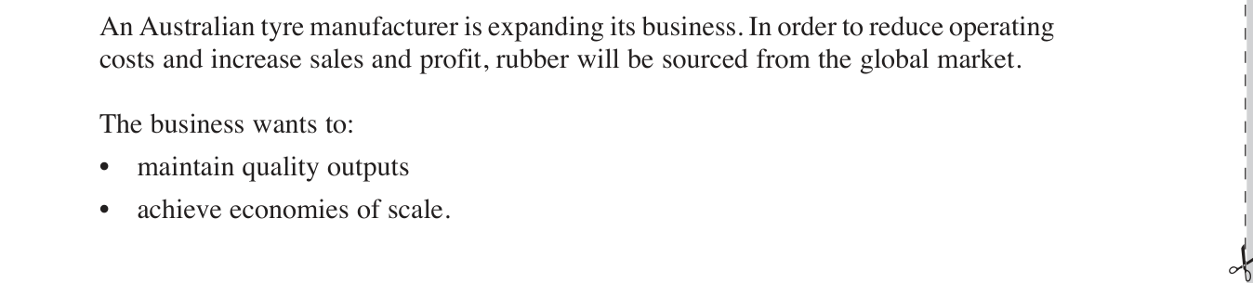
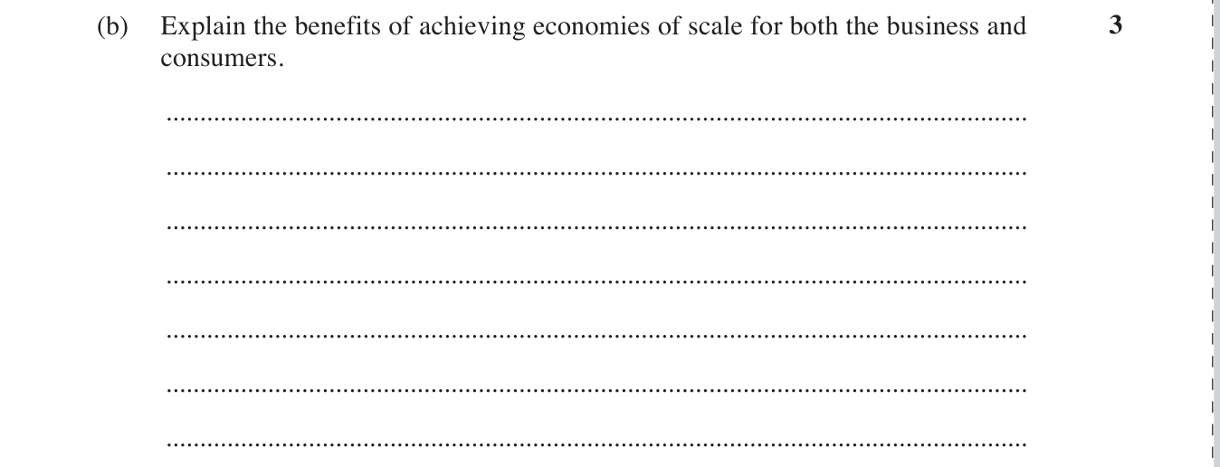

6. Quality management
2021 HSC — Question 21 (c) (4 marks)
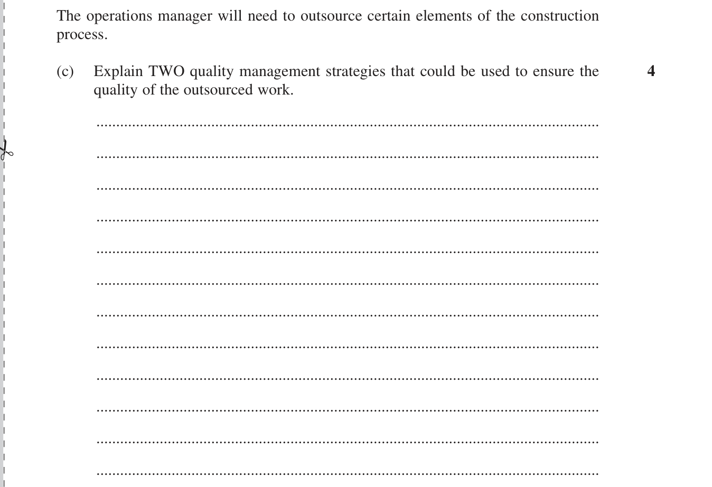
Roseville Trial 2023 — Question 21 (c) (4 marks)
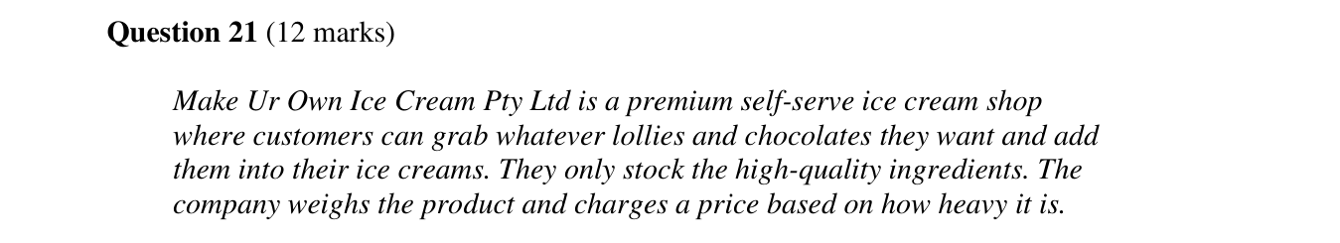
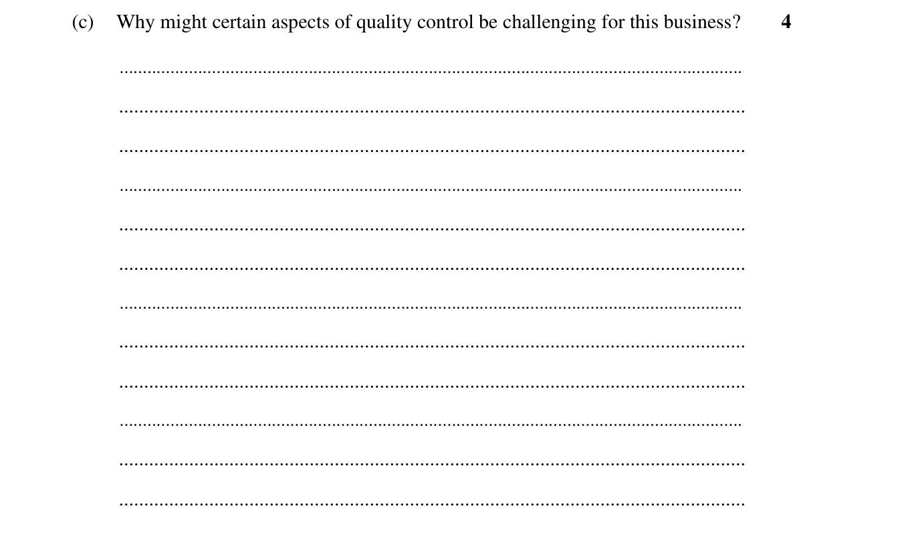

Multiple Choice
2021 HSC — Q11 — global sourcing (supply chain / global factors) (1 marks)
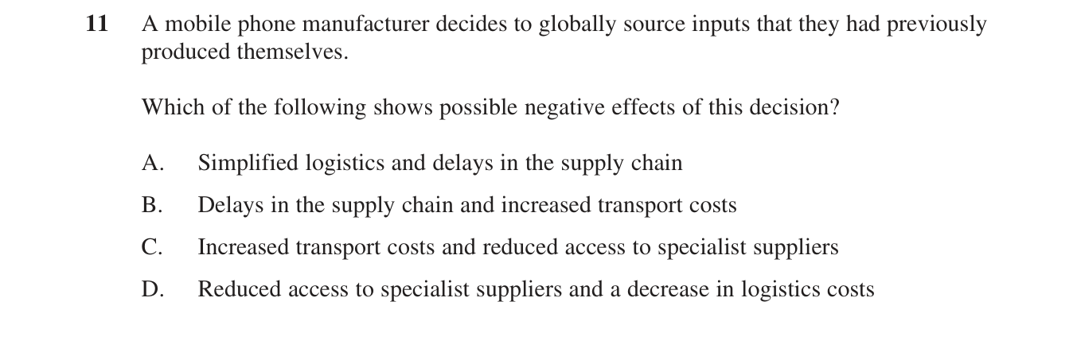
Knox Trial 2023 — Q17 — JIT inventory management (1 marks)
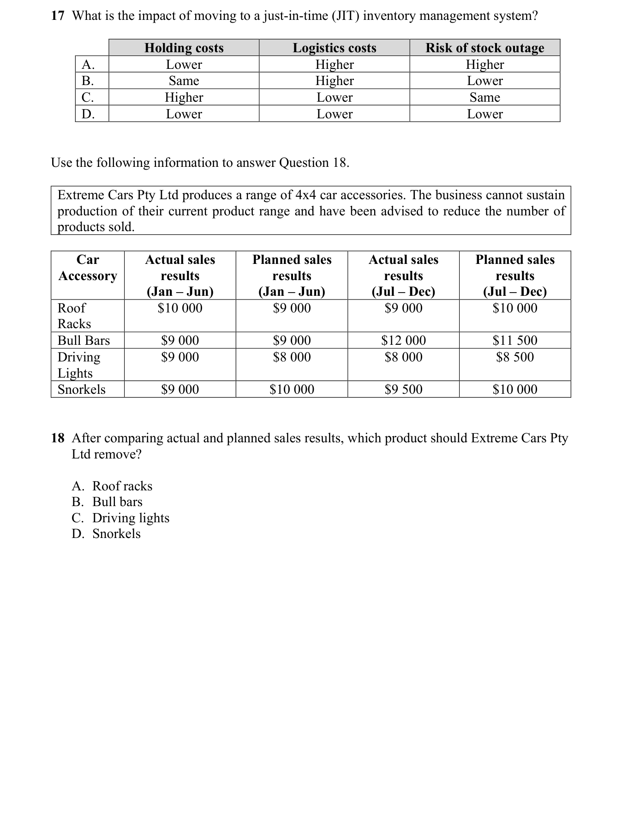
2019 HSC — Q9 — quality management (1 marks)
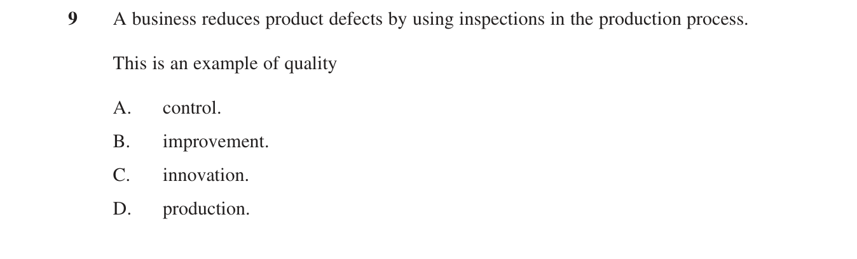

Extended Response
All operations extended responses from your papers that hit RED points (business reports excluded).
2019 HSC — Question 27 (20 marks)
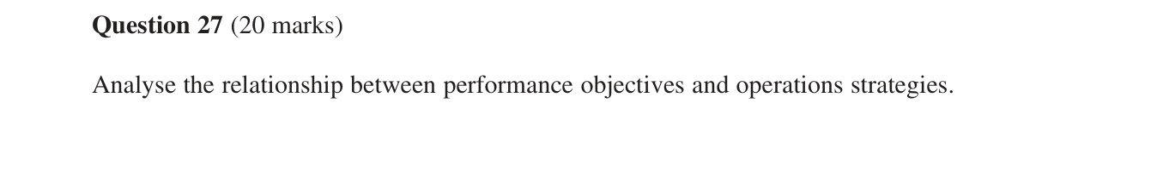
Abbotsleigh Trial 2023 — Question 26 (20 marks)
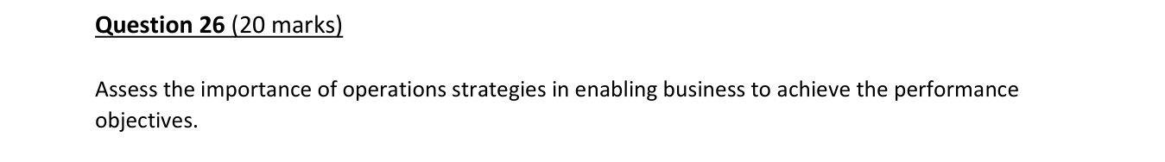
Barker Trial 2023 — Question 27 (20 marks)
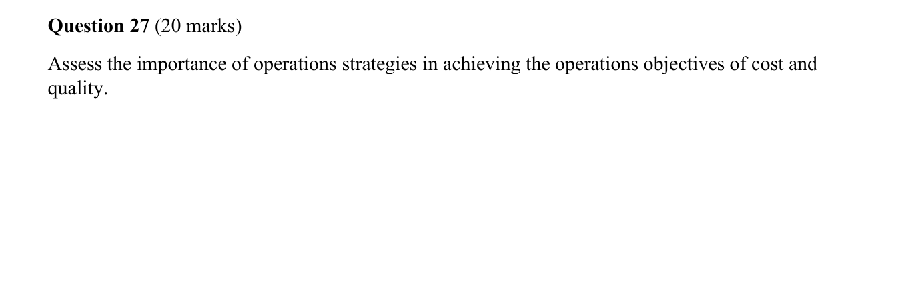
Barker Trial 2024 — Question 27 (20 marks)
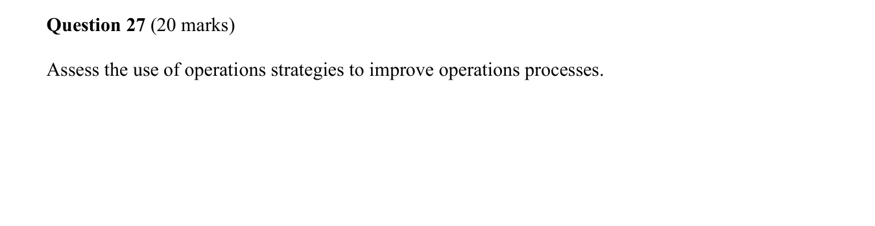
Newington Trial 2023 — Question 26 (20 marks)
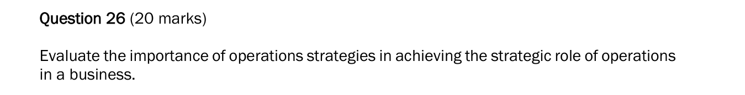
Roseville Trial 2023 — Question 26 — supply chain management & outsourcing (20 marks)
